***Software Testing {Assignment}***

Student Name: Keval Patel

* **MODULE – 4 Automation Core Testing (Load Runner Up and Selenium IDE)**

**Question .1}** **Which components have you used in Load Runner?**

**Answer**:

*Virtual user generator

**Question .2} How can you set the number of Vusers in Load Runner?**

**Answer**:

You can set the number of Vusers in the controller section while creating your scenarios. Many other advanced options like ramp-up, ramp-down of Vusers are also available in the Controller section.

**Question .3} What is Correlation?**

**Answer**:

Correlation is a process of capturing and storing the dynamic response from the server and passing it in the subsequent requests.

**Question .4} What is the process for developing a Vuser Script?**

**Answer**:

There are 5 steps for developing a vuser script.

1- Recording the vuser script.

2- Edit the vuser script.

3- Runtime setting.

4- Run the vuser script in stand-alone mode.

5- Incorporate the vuser script into a load runner scenario.

**Question .5}**  **How Load Runner interacts with the application?**

**Answer**:

Load Runner simulates user activity by generating messages between application components or by simulating interactions with the user interface such as key presses or mouse movements. The messages and interactions to be generated are stored in scripts.

**Question .6} How many VUsers are required for load testing?**

**Answer**:

This tool is capable of simulating hundreds of thousands of users, putting applications under real life loads to determine their behavior under expected loads (Hp Load Runner).Example- if you run a load test with 10,000 virtual users, each making a request every 20 seconds (3 requests per minute), then you're making 30,000 requests per minute, which equals 500 requests per second.

**Question .7} What is the relationship between Response Time and Throughput?**

**Answer**:

Response time and throughput are related. The response time for an average transaction tends to decrease as you increase overall throughput. However, you can decrease the response time for a specific query, at the expense of overall throughput, by allocating a disproportionate amount of resources to that query.

**Question .8} What is the difference between hits/second and requests/second?**

**Answer**:

Hits/second are the numbers of HTTP requests made by VUsers0 to the Web Server in a scenario or session step run on a per second basis. Requests/second are the numbers of requests completed during each second of scenario run.

**Question .9}create a normal script of above website with correlate using hp default website**

**Answer**:

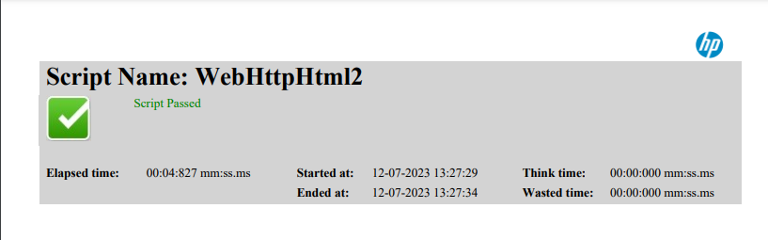

**Selenium IDE)**

**Question .1}What is Automation Testing?**

**Answer**: Automation Testing is a software testing technique that performs using special automated testing software tools to execute a test case suite. On the contrary, Manual Testing is performed by a human sitting in front of a computer carefully executing the test steps.

**Question .2} Which Are The Browsers Supported By Selenium Ide?**

**Answer**:

Different Browsers Supported By Selenium Ide

e.g.- Firefox, chrome

**Question .3}** **What are the benefits of Automation Testing?**

**Answer**: Hear are the key benefit

1. 70% faster than the manual testing
2. Wider test coverage of application features
3. Reliable in results
4. Ensure Consistency
5. Saves Time and Cost
6. Improves accuracy
7. Human Intervention is not required while execution
8. Increases Efficiency
9. Better speed in executing tests

10. Re-usable test scripts

11. Test frequently and thoroughly

12. More cycle of execution can be achieved through automation

13. Early time to market

**Question .4} What are the advantages of Selenium?**

**Answer**: Advantage of Selenium

1. Very easy to use and install.
2. No programming experience is required, through knowledge of HTML and DOM are needed.
3. Can export tests to formats usable in Selenium RC and WebDriver.
4. Have built-in help and test results reporting module.
5. Provides support for extensions.

**Question .5} Why testers should opt for Selenium and not QTP?**

**Answer**: Selenium, however, supports a wide range of programming languages. QTP/UFT test scripts run only on the Windows environment. They cannot be run across all browsers. On the other hand, Selenium is OS independent and allows test scripts to run across all browsers.